**IBM Assignment 1**

**Exploring the profit from the Startup’s dataset with Cognos Analytics.**

**Target variable:** Profit

**Cognos Analytics Link:** <https://us3.ca.analytics.ibm.com/bi/?perspective=explore&pathRef=.my_folders%2FIBM%2BAssignment%2FIBM%2Bassignment%2B1&subView=model000001835018e1e7_0000001>

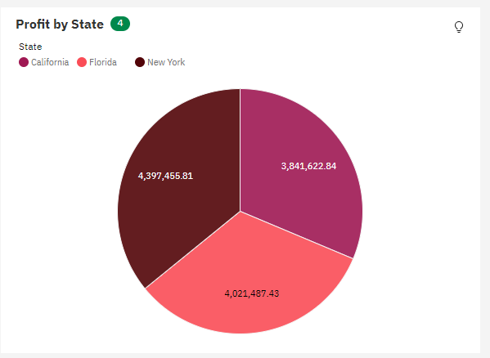

* From the pie chart it is inferred that Total Profit of New York is the highest.

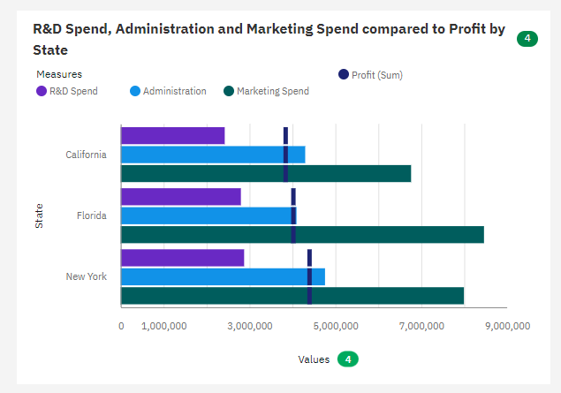

Observing the above Bar graph, It is clear that

* Florida has spent more money in Marketing
* New York has spent more money in Administration
* There is only a slight variation in R&D spend by the three cities.

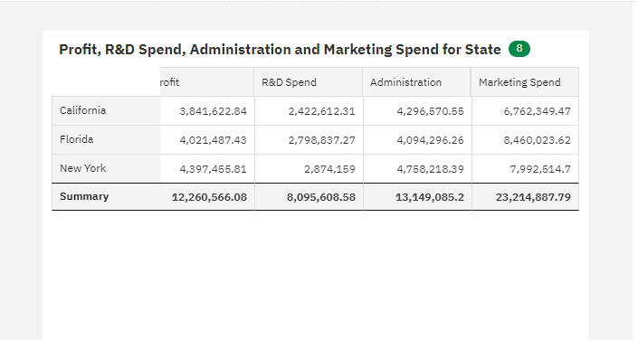

* Finally we can conclude that Profit of each city increases with increase in R&D spend.
* Hence R&D spend and Profit are directly proportional.